Real-time Programming
Assignment 1
Currency app
I M Bouaraba

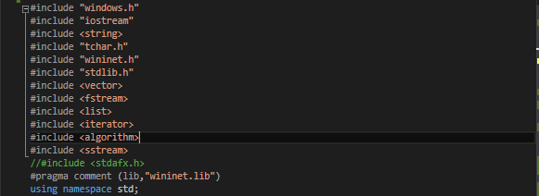
As you can see most of the library's used are quite standard, had quite a lot of trouble with wininet.h and getting it to connect but that turned out to be a bad URL in the end.

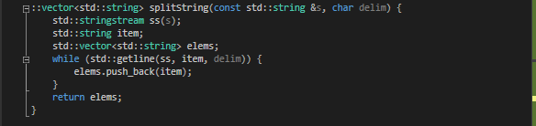
This function takes data recovered from the API and breaks it down into a vector string for better storage and latter to be turned in Doubles and strings.

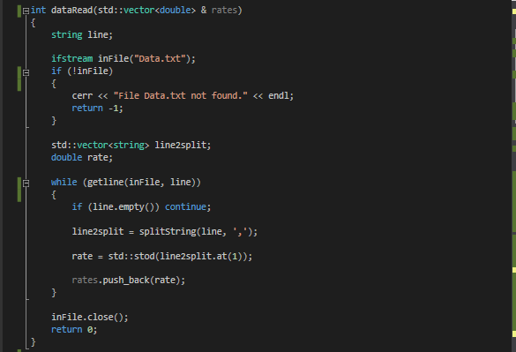
This function reads from the the data file from the yahoo API and extracts the rate from each line after turning the rate into a double for easy processing. Using the handy comma's in the API feed and a separator. In the final part it pushes the values down the list and writes them to file.

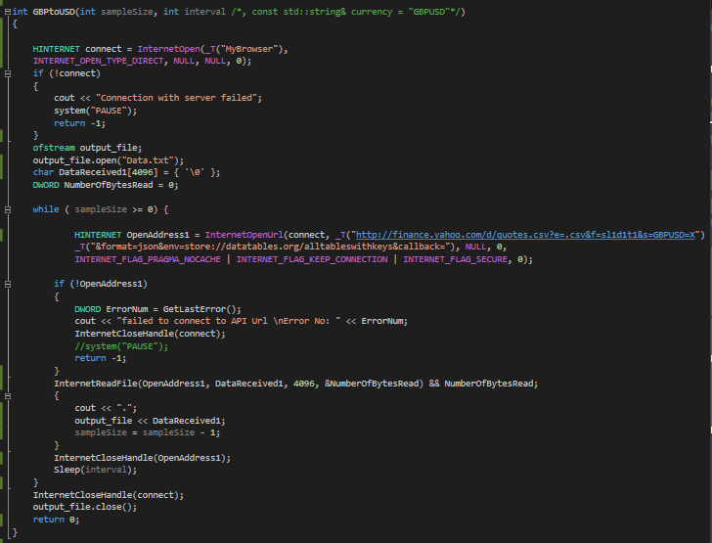
This function establishes a connection with the API (also includes fail safes if connection is not made), it then opens a file, if it's not present it makes it. It then stores the whole data string as a char taking advantage of the while loop to propagate the list of data. Then makes sure to close any connection left open after.
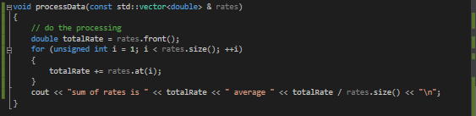
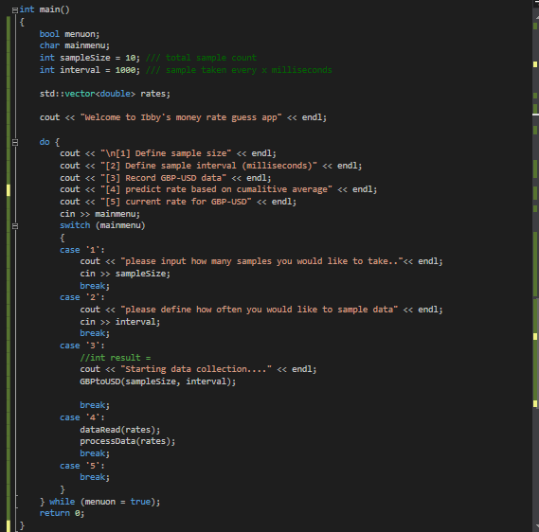
This code works out a possible future value by calculating and average of data file collected by the user, it quickly shuffles through the list using a for loop.

The main function acts as a main menu for the user to choose what they want to do and also preconfigure the collection process of data collection. This is done via option 1 and 2. sample size defines how many samples the app will take in total regardless of amount of time taken between each sample, that's where sample interval comes in. it is recommended for the best prediction to set the sample size in the range of 250-500 with an interval of 2000-5000 millisecond interval.

Example Raw data.
"GBPUSD=X",1.4219,"3/9/2016","7:14pm"
"GBPUSD=X",1.4218,"3/9/2016","7:14pm"
"GBPUSD=X",1.4219,"3/9/2016","7:14pm"
"GBPUSD=X",1.4219,"3/9/2016","7:14pm"
"GBPUSD=X",1.4218,"3/9/2016","7:14pm"
"GBPUSD=X",1.4218,"3/9/2016","7:14pm"
"GBPUSD=X",1.4219,"3/9/2016","7:14pm"
"GBPUSD=X",1.4218,"3/9/2016","7:14pm"
"GBPUSD=X",1.4218,"3/9/2016","7:14pm"
"GBPUSD=X",1.4220,"3/9/2016","7:14pm"
"GBPUSD=X",1.4219,"3/9/2016","7:14pm"
"GBPUSD=X",1.4219,"3/9/2016","7:14pm"
"GBPUSD=X",1.4219,"3/9/2016","7:14pm"

Conclusion
Keeping in mind this is one of the first c++ programmes I've written and prior to starting this module had never written a thing in c++ apart from a dice roller, I feel I have learned a lot about debugging code that doesn't always have a directly apparent issue, also learned that there is a whole lot of decent library that have so many uses, looking forward to exploring more of c++ and the many perils it has to offer.
In retrospect I would have liked to diversify the app further to provide more insightful predictions and features. But also knowledge is key and feel that as coming from a ART and design background the experience of this module so far has enriched my pallet for programming.

